Republic of the Philippines BARANGAY CULIAT
District VI, Quezon City Tel. No. 475-78-73

JAZER JAMES COQUILLA PERDANIO
Address: 35 Atis St. Purok 3, Luzon Ave. Culiat, QC Birth Date: 02-10-2002 Gender: Male
Status: Single Residency: Renter Precinct No: None SSS/GSIS No: None Tin No: None
SA BRGY. CULIAT SERBISYO AY TAPAT LUNES HANGGANG LINGGO TULOY-TULOY ANG SERBISYO





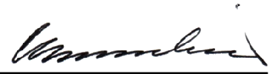
ID No: 21-08487

Signature
The Cardholder whose name, and photo appear on this card is bonafide resident of this barangay.

In case of loss of this card, please notify Barangay Administration Office and apply for a replacement. The same charges shall apply.

Date of Issue: 06/28/2021
Date of Expiration: 06/28/2022 CRISTINA V. BERNARDINO
Punong Barangay
IN CASE OF EMERGENCY PLEASE NOTIFY:
Name: Jenelyn C. Perdanio Relationship: Mother Contact No: 09476341926
Address: 25 Atis St. Purok 3, Luzon Ave. Culiat, Qc

